RUNYANG BRIDGE

BRIDGE

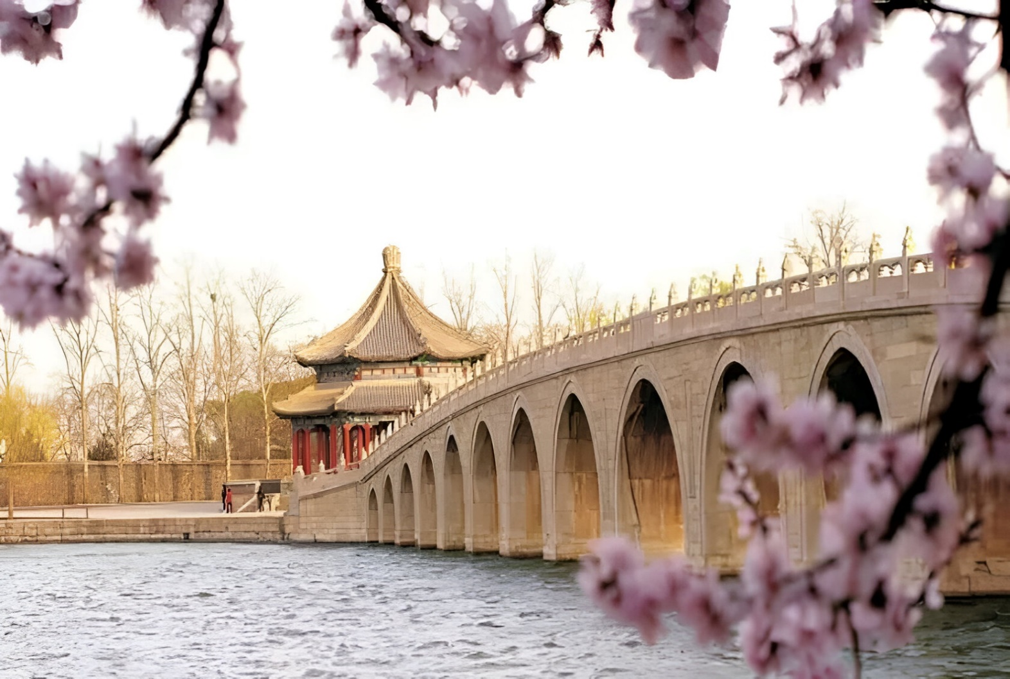

The Runyang Bridge, a breathtaking testament to human engineering, spans across the mighty Yangtze River in Jiangsu Province, China, embodying the nation's pursuit of infrastructure excellence and connectivity. Comprising two main spans, the Runyang Bridge complex includes both the Runyang Yangtze River Bridge and the Runyang North Bridge, forming an essential part of the country's extensive transportation network. Towering high above the river's swirling currents, the bridge complex stretches over 35.66 kilometers (22.15 miles), making it one of the longest bridges in the world. Constructed with cutting-edge engineering techniques and materials, the Runyang Bridge is a marvel of modern design and construction. Its graceful arches and soaring towers are a testament to the ingenuity and skill of the engineers and workers who brought this monumental project to life. The bridge's towering pillars rise majestically from the riverbed, supporting a massive deck that carries thousands of vehicles and travelers each day, facilitating the flow of commerce and transportation between regions. The bridge's sleek, contemporary design blends seamlessly with the surrounding landscape, creating a harmonious fusion of man-made and natural elements. Whether bathed in the golden light of dawn or illuminated by the twinkling lights of nightfall, the Runyang Bridge stands as a beacon of progress and modernity, a symbol of China's emergence as a global economic powerhouse.